**COMPONENT AND DEPLOYMENT DIAGRAMS**

**AIM:**

To design component and deployment diagrams for Online Exam Registration System.

**DEFINITION:**

In the Unified Modelling Language, a component diagram depicts how components are wired together to form larger components or software systems. They are used to illustrate the structure of arbitrarily complex systems.

Deployment diagram is a structure diagram which shows architecture of the system as deployment (distribution) of software artifacts to deployment targets. Artifacts represent concrete elements in the physical world that are the result of a development process.

**COMPONENT DIAGRAM:**

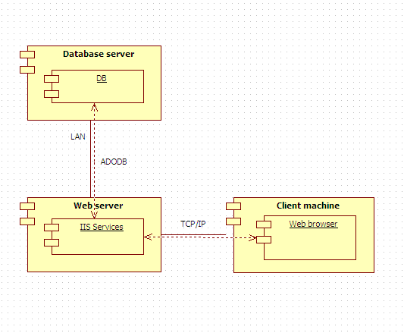

**DEPLOYMENT DIAGRAM:**

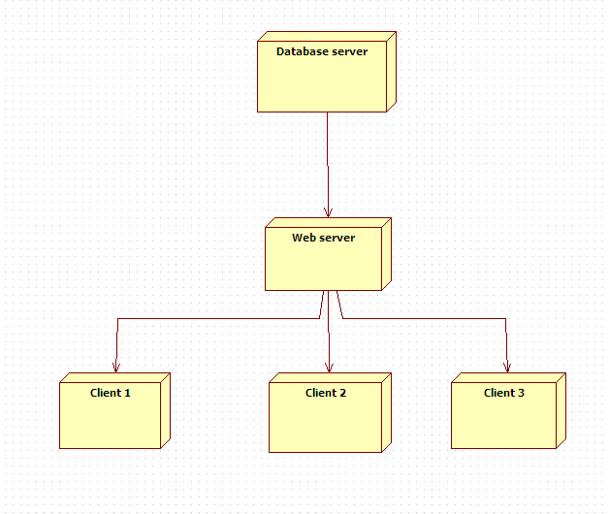

**RESULT:**

Thus the respective component and deployment diagrams have been designed for the Exam Registration System.